# **Name: Abdurrahman Qureshi**

# **Roll No: 242466**

Practical No: 7

**1)** **Demonstrate advance methods** of AVL tree.

CODE

#include <stdio.h>

typedef *struct* node

{

*int* data;

*struct* node *left, *right;

*int* ht;

} node;

node *insert(node *, *int*);

node *Delete(node *, *int*);

*void* preorder(node *);

*void* inorder(node *);

*int* height(node *);

node *rotateright(node *);

node *rotateleft(node *);

node *RR(node *);

node *LL(node *);

node *LR(node *);

node *RL(node *);

*int* BF(node *);

*int* main()

{

    node *root = NULL;

*int* x, n, i, op;

    do

    {

        printf("\n1)Create:");

        printf("\n2)Insert:");

        printf("\n3)Delete:");

        printf("\n4)Print:");

        printf("\n5)Quit:");

        printf("\n\nEnter Your Choice:");

        scanf("%d", &op);

        switch (op)

        {

        case 1:

            printf("\nEnter no. of elements:");

            scanf("%d", &n);

            printf("\nEnter tree data:");

            root = NULL;

            for (i = 0; i < n; i++)

            {

                scanf("%d", &x);

                root = insert(root, x);

            }

            break;

        case 2:

            printf("\nEnter a data:");

            scanf("%d", &x);

            root = insert(root, x);

            break;

        case 3:

            printf("\nEnter a data:");

            scanf("%d", &x);

            root = Delete(root, x);

            break;

        case 4:

            printf("\nPreorder sequence:\n");

            preorder(root);

            printf("\n\nInorder sequence:\n");

            inorder(root);

            printf("\n");

            break;

        }

    } while (op != 5);

    return 0;

}

node *insert(node \**T*, *int* *x*)

{

    if (*T* == NULL)

    {

*T* = (node *)malloc(sizeof(node));

*T*->data = *x*;

*T*->left = NULL;

*T*->right = NULL;

    }

    else

        if (*x* > *T*->data) // insert in right subtree

    {

*T*->right = insert(*T*->right, *x*);

        if (BF(*T*) == -2)

            if (*x* > *T*->right->data)

*T* = RR(*T*);

            else

*T* = RL(*T*);

    }

    else if (*x* < *T*->data)

    {

*T*->left = insert(*T*->left, *x*);

        if (BF(*T*) == 2)

            if (*x* < *T*->left->data)

*T* = LL(*T*);

            else

*T* = LR(*T*);

    }

*T*->ht = height(*T*);

    return (*T*);

}

node *Delete(node \**T*, *int* *x*)

{

    node *p;

    if (*T* == NULL)

    {

        return NULL;

    }

    else if (*x* > *T*->data) // insert in right subtree

    {

*T*->right = Delete(*T*->right, *x*);

        if (BF(*T*) == 2)

            if (BF(*T*->left) >= 0)

*T* = LL(*T*);

            else

*T* = LR(*T*);

    }

    else if (*x* < *T*->data)

    {

*T*->left = Delete(*T*->left, *x*);

        if (BF(*T*) == -2) // Rebalance during windup

            if (BF(*T*->right) <= 0)

*T* = RR(*T*);

            else

*T* = RL(*T*);

    }

    else

    {

        // data to be deleted is found

        if (*T*->right != NULL)

        { // delete its inorder succesor p=T->right; while(p->left!= NULL) p=p->left; T->data=p->data;

*T*->right = Delete(*T*->right, p->data);

            if (BF(*T*) == 2) // Rebalance during windup if(BF(T->left)>=0)

*T* = LL(*T*);

            else

*T* = LR(*T*);

        }

        else

            return (*T*->left);

    }

*T*->ht = height(*T*);

    return (*T*);

}

*int* height(node \**T*)

{

*int* lh, rh;

    if (*T* == NULL)

        return (0);

    if (*T*->left == NULL)

        lh = 0;

    else

        lh = 1 + *T*->left->ht;

    if (*T*->right == NULL)

        rh = 0;

    else

        rh = 1 + *T*->right->ht;

    if (lh > rh)

        return (lh);

    return (rh);

}

node *rotateright(node \**x*)

{

    node *y;

    y = *x*->left;

*x*->left = y->right;

    y->right = *x*;

*x*->ht = height(*x*);

    y->ht = height(y);

    return (y);

}

node *rotateleft(node \**x*)

{

    node *y;

    y = *x*->right;

*x*->right = y->left;

    y->left = *x*;

*x*->ht = height(*x*);

    y->ht = height(y);

    return (y);

}

node *RR(node \**T*)

{

*T* = rotateleft(*T*);

    return (*T*);

}

node *LL(node \**T*)

{

*T* = rotateright(*T*);

    return (*T*);

}

node *LR(node \**T*)

{

*T*->left = rotateleft(*T*->left);

*T* = rotateright(*T*);

    return (*T*);

}

node *RL(node \**T*)

{

*T*->right = rotateright(*T*->right);

*T* = rotateleft(*T*);

    return (*T*);

}

*int* BF(node \**T*)

{

*int* lh, rh;

    if (*T* == NULL)

        return (0);

    if (*T*->left == NULL)

        lh = 0;

    else

        lh = 1 + *T*->left->ht;

    if (*T*->right == NULL)

        rh = 0;

    else

        rh = 1 + *T*->right->ht;

    return (lh - rh);

}

*void* preorder(node \**T*)

{

    if (*T* != NULL)

    {

        printf("%d(Bf=%d)", *T*->data, BF(*T*));

        preorder(*T*->left);

        preorder(*T*->right);

    }

}

*void* inorder(node \**T*)

{

    if (*T* != NULL)

    {

        inorder(*T*->left);

        printf("%d(Bf=%d)", *T*->data, BF(*T*));

        inorder(*T*->right);

    }

}

OUTPUT

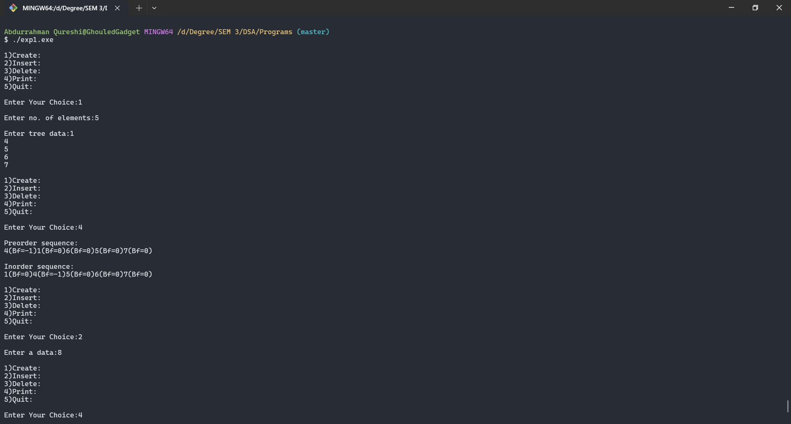

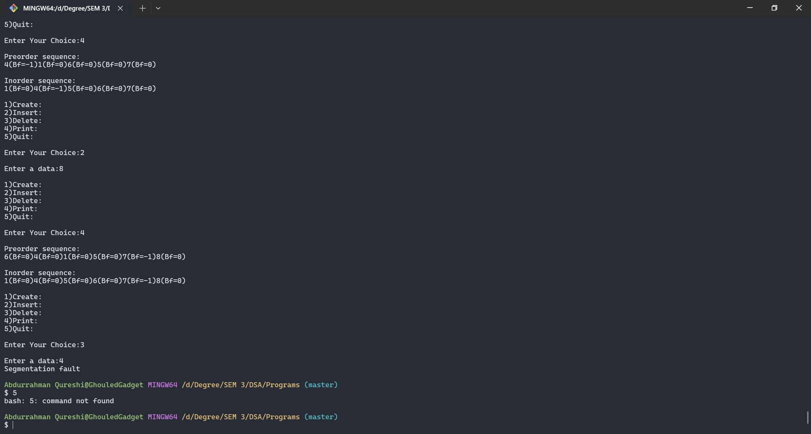

Tools used :

Software: Dev c++

Hardware: Lab Computers

References: Mam notes.

Conclusion

* AVL tree is a descendant of Binary Search Tree but overcomes its drawback of increasing complexity if the elements are sorted.
* It monitors the balance factor of the tree to be 0 or 1 or -1.
* In case it tree becomes unbalanced corresponding rotation techniques are performed to balance the tree.